FORM A1: APPLICATION SUBMISSION SHEET

Date: 23 August 2026

To:
Financial Sector Deepening Uganda
Plot 20B, Kawalya Kaggwa Close - Kololo
P.O. Box 608 Kampala, Uganda

We/I, the undersigned declare that:

(a) I have examined and have no reservations to the solicitation document.

(b) I hereby apply to be procured as a Data Scientist.

(c) I, including any subcontractors or providers for any part of the contract or contracts resulting from this procurement process, are eligible to participate in public procurement;

(d) I undertake to abide by the Code of Ethical Conduct for Providers and Providers during the procurement process and the execution of any resulting contract;

(e) I, our affiliates or subsidiaries, including any subcontractors for any part of the contract or contracts resulting from this procurement process, have not been suspended by the Public Procurement and Disposal of Public Assets Authority in Uganda from participating in public procurement;

(f) I understand that you may amend the scope and value of any contracts to be application or cancel the procurement process at any time and that you are neither bound to accept any application that you may receive nor to invite the successful applicants to bid for the contract or contracts, which are the subject of this procurement process, without incurring any liability to the Applicants;

(g) I understand that qualification information may be subject to verification through a post-qualification or due diligence process prior to any award of contract;

(h) I hereby authorise you and your authorised representatives, to conduct any enquiries or investigations to verify the statements, documents and information submitted in connection with this application and to seek clarification from our bankers and clients regarding any financial and technical aspects. This Application Submission Sheet will also serve as authorisation to any individual or authorised representative of any institution referred to in the supporting information to provide such information deemed necessary and as requested by yourselves to verify statements and information provided in this application.

Signed: 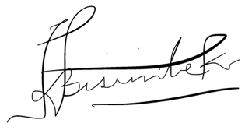
Name: Remmy Bisimbeko
In the capacity of: Individual Consultant
Duly authorised to sign the application for and on behalf of: Remmy Bisimbeko

Dated on 23rd day of August, 2026

